Indiana State Police K-9
Funeral Manual
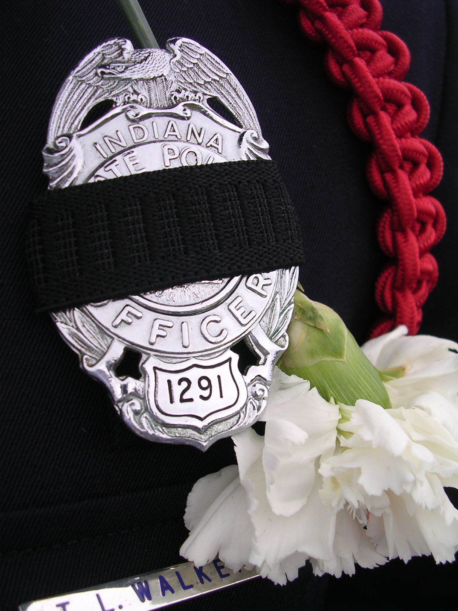
Indiana State Police K-9
Funeral Manual
Line of Duty and Active (Non Line of Duty)

The death of a K-9 member of the Indiana State Police force is a tragedy. The dogs give their all to do their job and ask for nothing in return. Therefore, it seems only appropriate that when a dog is killed in the line of duty or dies while in duty, that their services are honored. However, there is another component to this memorialization process and that is also honoring the dog’s handler and partner. The saying “funerals are for the living” is accurate so this process is mostly about honoring the work that the team did together during their partnership.

When the Indiana State Police is responsible for conducting a funeral for a K-9 member, the following procedures shall be followed. The level of the intensity of the memorial services is defined by either a death in the line of duty or a death during the active duty of the dog. A description of each level is listed below followed by detailed procedures for conducting the particular memorial service type.

For the purposes of these protocols, cremation is performed as the final disposition of the body. If burial is preferred, it would be by the handler’s request

Level I Memorial Service

K-9 Killed in the Line of Duty

After the K-9 Department Coordinator has been made aware of a line-of-duty death, a joint session will be conducted to review the funeral procedures. The Memorial Services Team shall include the Department command, clergy, Pet Loss Professional Alliance pet loss operation the handler and Honor Guard Commander. The purpose of the meeting is to coordinate resources and services needed to conduct the memorial service.

This K-9 Coordinator and the Honor Guard Commander will be responsible for getting the appropriate information to the PLPA member for the printed service cards, communication with the participating members of the service, and any other needs of the event.

When the department is ready to release the dog’s body, a call is made to the Pet Loss Professional’s Alliance pet loss professional Coleen Ellis. Her contact information is listed below. The dog’s body will then be picked up. A call will be placed to the handler and his family. The handler and his family will have the opportunity for a private visitation at the Pet Loss Professional’s operation.

This visitation will take place within a day or two of the death of the dog.
ICCFA/PLPA
107 Carpenter Drive, Suite 100
Sterling, Virginia 20164
1-703-391-8400
Primary Indian contact: Coleen Ellis
Cell-317-966-0096
Work-317-884-4885
Email-Coleen@TwoHeartsPetLossCenter.com

When the handler is ready, the PLPA firm will proceed with the cremation. The cremation will be a private cremation; the dog’s body will be the only body in the retort. A fur clipping and a clay paw print will be done prior to cremation for the handler and his family to keep.

The PLPA will donate and provide the following services and items for the service:
Cremation, Photo, Urn, Service Cards, Burial(if needed), casket and vault

Upon receipt of an appropriate photo, the PLPA firm will then place the call to order the urn.

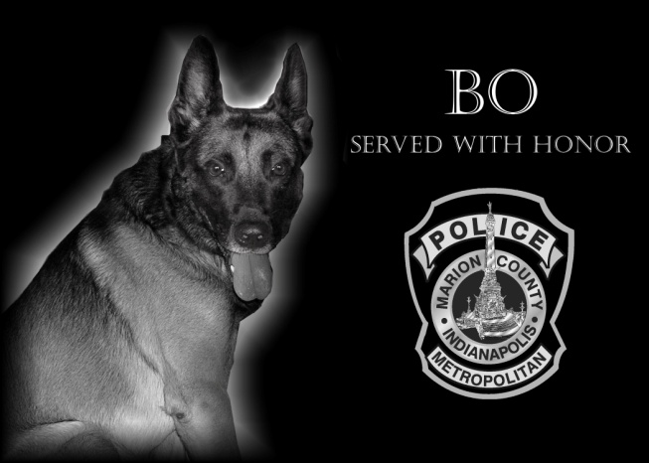

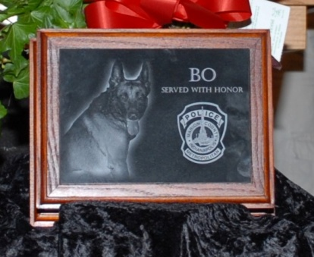

The service will be set for two (2) weeks after the death of the dog has happened. During this time, the Memorial Services Team will:

LEVEL I PROCEDURES – K-9 Killed in the Line of Duty

A. Prior to the service beginning, the stage will be set. A Proclamation provided by the Indiana State Police Public Information Office will be placed on a small easel by the dog’s photograph and urn. The stage will also include the flowers that have been sent.

Prior to the actual service starting, the K-9 department members and their family will proceed in ceremoniously to be seated. The deceased K-9’s handler and family will then follow to be seated in the front row of the auditorium.

B. The beginning of the service….The designated Command person and the K-9 Coordinator will march up to the Memorial location at the front of the facility and stop. At that time the Command person shall proceed to the podium and read the proclamation. After the reading the Command person will walk over to the Honor Guard and hand the proclamation to him for placement on an easel at the Memorial. After placement the Command shall rejoin the K-9 Coordinator and march off.

The service will also include this reading:

The Life of a Police Dog

You brought me home
One sunny day
With you for years
I would surely stay.

I met your pack
Children and wife
I began to love
My new-found life.

I slept on your couch
At the foot of your bed
You looked at me lovingly
While petting my head.

We trained for months
And our bonding grew
We were both partners
Buddies in Blue.

We did school demos
And I never did wrong
Over all the years
My love for you grew strong.

How I loved to work
To stand up and bark
In the back of our car
From light until dark.

We went call to call
Having fun all the way
Until the call came
On that one fateful day.

A man with a gun
The dispatcher did say
I jumped from my car
When it pointed your way.

Before leaving home I was told
“Keep him safe” by your wife
I knew at that moment
For you I would give my life.

The bullet struck hard
Steady and true
The bullet struck me instead
Of striking you.

When you go home tonight
Tell your wife I did good
Strong, Tall and Proud
On the ground that I stood.

I’m dead and gone now
This much is true
But I’ve done my job well
Of protecting you.

Thank you
Loyal partner,
Faithful friend,
You will be greatly missed.

- Author Unknown

Level II Memorial Service

K-9 Death Active (Non Line of Duty)

After the K-9 Department Coordinator has been made aware of an Active (Non Line of Duty) death, a joint session will be conducted to review the funeral procedures. The Memorial Services Team shall include the Department command, clergy, Pet Loss Professional Alliance pet loss operation the handler and Honor Guard Commander. The purpose of the meeting is to coordinate resources and services needed to conduct the memorial service.

LEVEL II PROCEDURES-ACTIVE (NON LINE OF DUTY)

This K-9 Coordinator and the Honor Guard Commander will be responsible for getting the appropriate information to the PLPA, communication with the participating members of the service, and any other needs of the event.

When the department is ready to release the dog’s body, a call is made to the Pet Loss Professional’s Alliance pet loss professional Coleen Ellis. Her contact information is listed below. The dog’s body will then be picked up. A call will be placed to the handler and his family. The handler and his family will have the opportunity for a private visitation at the Pet Loss Professional’s operation. This visitation will take place within a day or two of the death of the dog.

Upon receipt of an appropriate photo, the PLPA firm will then place the call to order the urn.

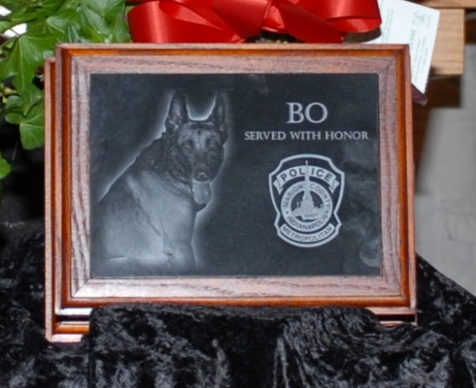

The service will be set for two (2) weeks after the death of the dog has happened.

A service for the K-9, his handler and family as well as participants from the K-9 force will be held. The service will be appropriate to honor the dog’s service to the community as well as the life of the dog.

The service will be held at the District Facility in which the K-9 handler is assigned.

The service shall include remarks by:
Clergy
Department Command
K-9 Coordinator
Assigned K-9 Handler

(Effective: 10-3-2011)

